Tender Covering Form Directorate of Procurement (Navy) Through Bahria Gate
Contact: Reception 051-9262311, Bahria Gate 0331-5540649, Section: 051-9262307 Email: dpn@paknavy.gov.pk 051-9262307 adpn36@paknavy.gov.pk
P-36/FOR Section (Contact: 051-9262307, Email: adpn36@paknavy.gov.pk)

Tender No and Date R2412360246
Tender Description PROCUREMENT OF 02 X RHD, HIACE (HI-ROOF), BAISC AMBULANCE
IT Opening Date 21/01/2025
Firm Name Postal Address Email Address for Correspondence Contact Person Contact Number (Landline ) (Mobile ) Document to be Attached with Quotation
Firm is to submit its proposal in a sealed envelope which shall contain 03 x Sealed Envelops as per details given below:

Sealed Envelop 1 – Technical Offer in Duplicate
This envelope must contain 02 x sets of Technical Offer (01 x Original + 01 x Copy). Each Set must contain following documents as per this order and Supplier is to mark tick against each to ensure that these documents have been
S No | Document | Original Set | Copy Set
1 | Bank Challan of Rs. 200/- for DGDP registered firms and Rs. 300/- for all other firms (in favour of CMA(DP))
2 | DP-1 Form of IT with tick markagainst each clause and initiated on each page
3 | DP-2 Form of IT with compliance remarks against each clauseand initiated on each page
4 | Annex A of IT duly filled (with compliance remarks)
5 | Annex B & C of IT (with compliance remarks)
6 | DP-3 Form of IT (duly filled & Signed)
7 | Manufacturer Authorization letter (where applicable)
8 | Manufacturer Price list (where applicable)
9 | DRAP registration letter (in case of medical)
10 | DGDP Registration Letter (If firm is registered with DGDP)
11 | Tax Filling Proof
Sealed Envelop 2 – Earnest Money
This Envelop must contain Earnest Money only.
Sealed Envelop 3 – Commercial Offer
This Envelop must contain following documents:
1 | Firms Commercial Offer | 01 x Original
2 | Principal Invoice (where applicable) | 01 x Original
3 | Duly filled DP-2 Form of IT | 01 x Original
Firms Declaration
It is certified that we have submitted tender in compliance with above instructions nd we understand

Firm's Authorized Signatures
DP - I

DIRECTORATE PROCUREMENT (NAVY)

Directorate of Procurement (Navy)
Through Bahria Gate Near SNIDS Centre,
Naval Residential Complex
Contact: Reception: 051-9262311
Bahria Gate: 0331-5540649
Section: 051-9262307

Email: dpn@paknavy.gov.pk
adpn36@paknavy.gov.pk

M/s

Dated :

INVITATION TO TENDER AND GENERAL INSTRUCTIONS

Dear Sir / Madem,

- DP (Navy) invites you to tender for the supply of stores/equipment/ services as per details given in attached Schedule to Tender (Form DP-2).

- Caution:
This tender and subsequent contract agreement awarded to

Understood

Understood

.the successful bidder is governed by the rules / conditions as laid down in PPRA Rules-2004 and DPP&I-35 (Revised 2019) covering general terms and conditions of contracts laid down by MoDP / DGDP. As a potential bidder, it is incumbent upon you and your firm to first acquaint yourself with PPRA Rules 2004 (www. ppra.org.pk) and DPP&I-35 (Revised 2023) (print copy may be obtained from DGDP Registration Cell on Phone No. 051-9270967 before participating in the tender. If your firm / company possesses requisite technical as well financial capability, you must be registered or willing to register with DGDP to qualify for award of contract, which shall be made after security clearance and provision of required registration documents mentioned in Para 15 of this DP-1.
agreed
not agreed

- Conditions Governing Contracts.
The 'Contract' made as result of this

Understood

Understood

.I/T (Invitation to Tender) i.a.w PPRA Rules 2004 shall mean the agreement entered into between the parties i.e. the „Purchaser and the „Seller on Directorate General Defence Purchase (DGDP) contract Form “DP-19” in accordance with the law of contract Act, 1872 and hose contained in Defence Purchase Procedure and Instructions and DPP&I-35 (Revised 2019) and other special conditions that may be added to given contract for the supply of Defence Stores / Services specified herein.
agreed
not agreed

- Delivery of Tender: The tender documents covering technical and
.commercial offers are to be furnished as under:-

  - Commercial Offer: The commercial offer will be in single copy and i.ndicate prices quoted in figures as well as in words in the currency mentioned in IT. It should be clearly marked in fact on a separate sealed envelope “Commercial Offer”, tender number and date of opening. Taxes, duties, freight/transportation, insurance charges etc are to be indicated separately. Total price of the items quoted against the tender is to be clearly mentioned. In case of more than one option offered by the firm, DP(N) reserves the right to accept lowest technically accepted option if more than one options were accepted in Technical Scrutiny Report.
Understood agreed

Understood not agreed

  - Technical Offer: (Where Applicable).
Should contain all
Understood
Understood

.relevant specifications in DUPLICATE (or as specified in IT) along with essential literature/brochure, drawings and compliance metrics in a separate sealed envelope and clearly marked “Technical Offer” without prices, with tender number and date of opening. Technical offer shall be opened first; half an hour after the date and time for receipt of tender mentioned in DP-2. Firms are to confirm/comply with IT technical specification in the following format:
agreed
not agreed

S. No | Technic al requirem ent as per IT | Firm’s endorsement (Comply/ Partially  Comply/ Non Comply | Basis of C, PC of NC i.e. Refer to page or brochure | In case of non availability of enclosed proof from brochure/ Literature, quote/ attach additional documents/ data/undertaking as proof of compliance
(Legend: C = Fully Comply, PC = Partially Comply, NC = Not Comply)
(Firms must clearly identify where their offer does not meet or deviates from IT Specs)

  - Special Instructions.
Tender documents and its conditions
Understood
Understood

.may please be read point by point and understood properly before quoting. All tender conditions should be responded clearly. In case of any deviation due to non-acceptance of tender conditions(s), the same should be highlighted alongwith your offered conditions. Tender may however be liable to be rejected.
agreed
not agreed

  - Firms shall submit their offers in two separate envelopes (i.e. one copy
.of commercial offer and two copies of the technical offers as asked in the IT) and envelops clearly marked “Technical proposal”, “Commercial proposal” in bold. The commercial offer will include rates of items/services called for and the technical offer will not indicate the rates. Both types of offers are to be enclosed in separate covers and each envelope shall be properly sealed bearing of the bidder. Each cover shall indicate type of offer, number and date of IT and IT opening date. Thereafter both the envelopes (technical and commercial offer) shall be placed in one envelope (second cover) duly sealed and signed. This cover should bear the address

of the procurement agency indicating, issuance date of IT and No, with its opening date. This should be further placed in another cover (third cover), addressed and indicated in the tender documents, without any indication that there is a tender within it.

  - FORM DP-1, DP-2, DP-3 and Questionnaires.
Form DP-1, DP-2

Understood

Understood

.(alongwith annexes), DP-3 and Questionnaires duly filled in are to be submitted with the technical offer duly stamped/signed by the authorized signatory/ person. It is pertinent to mention that all these are essential requirement for participation in the tender.
agreed
not agreed

f. The tender duly sealed will be addressed to the following:-

Directorate of Procurement (Navy)
Through Bahria Gate Near SNIDS Centre, Naval Residential
Contact: Reception: 051-9262311
Bahria Gate: 0331-
5540649
Section: 051-9262307 Email: dpn@paknavy.gov.pk
adpn36@paknavy.gov.

- Date and Time For Receipt of Tender.
Tender must reach this office

Understood

Understood

.by the date and time specified in the Schedule to Tender (Form DP-2) attached. This Directorate will not accept any excuse of delay occurring in post. Tenders received after the appointed/ fixed time will NOT be entertained. The appointed time will, however, fall on next working day in case of closed/forced holiday. Only legitimate/registered representatives of firm will be allowed to attend tender opening. In case your firm has sent tender documents by registered post or courier service, you may confirm their receipt at DP (Navy) on Phone No 051-9271468 well before the opening date / time.
agreed
not agreed

- Tender Opening.
Tenders will be opened as mentioned in the

Understood

Understood

.schedule to tender. Commercial offers will be opened at later stage if Technical Offer is found acceptable on examination by technical authorities of Service HQ. Date and time for opening of Commercial offer shall be intimated later. Only legitimate / registered representative of firm will be allowed to attend tender opening. Tenders received after date and time specified in DP-2 would be rejected without exception and returned un-opened i.a.w Rule 28 of PPRA-2004.
agreed
not agreed

- Validity of Offer.
  - The validity period of quotations must be indicated and should invariably be 120 days from the date of opening of Technical offer or 30th June whichever is later. Firm undertakes to extend validity of offer if required by equal number of original bid period (i.e. 120 days as per original offer) i.a.w PPRA Rule-26.
  - The quoting firm will certify that in case of an additional requirement of the contract items (s) in any qty(s) within a period of 12 months from the date of signing the contract, these will also be supplied at the ongoing contract rates with discount.

Understood agreed

Understood not agreed

- Part Bid
Firm may quote for the whole or any portion, or to state in
Understood
Understood

.the tender that the rate quoted, shall apply only if the entire quantity/range of stores is taken from the firm. The Director Procurement reserves the right of accepting the whole or any part of the tender or portion of the quantity offered, and firm shall supply these at the rate quoted.
agreed
not agreed

- Quoting of Rates.
Only one rate will be quoted for entire quantity, item

Understood

Understood

.wise. In case quoted rates are deliberately kept hidden or lumped together to trick other competitors for winning contract as lowest bidder, DP(N) reserves the right to reject such offers on-spot besides confiscating firms Earnest Money / Bid Security and take appropriate disciplinary action. Conversion rate of FE/LC components will be considered w.e.f. opening of commercial offer as per PPRA Rule-30(2).
agreed
not agreed

10.
Return of I/T.
ITs are to be handled as per following guidelines:

Understood

Understood

  - In case you are Not quoting, please return the tender inquiry stating the reason of NOT quoting. In case of failure to return the ITs either quoted or not quoted consequently on three occasions, this Directorate, in the interest of economy, will consider the exclusion of your firms name from our future distribution list of invitation to tender.
  - For registered firm(s), case will be referred to DGDP for necessary administrative action if firms registered / indexed for tendered items/stores do not quote / participate.
  - It is a standard practice to invite all firm(s) including those unregistered with DGDP who gave their preliminary budgetary/ technical proposals to end users / indentors. If your firm has been invited to participate in the tender, you must either participate in tender. In case of your inability to do so, you must inform DP (Navy) by a formal letter/email.
agreed
not agreed

11.
Withdrawal of Offer.
Firms shall not withdraw their commercial
Understood
Understood

offers before signing of the contract and within validity period of their offers. In case the firm withdraws its offer within validity period and before signing of the contract, Earnest Money of the firm shall be confiscated and disciplinary action may also be initiated for embargo up to 01 year.
agreed
not agreed

12.
Provision of Documents in case of Contract.
In case any firm wins

Understood

Understood

a contract, it will deposit following documents before award of contract:
- Proof of firms financial capability.
- Foreign Seller has to provide its Registration Number issued by respective Department of Commerce authorizing export of subject stores.
- Principal/Agency Agreement.
- Registration with DGDP (Provisional Registration is mandatory)
- Treasury Challan.
- Offers by registered firms must be accompanied with a Challan form of Rs.200/- (obtainable from State Bank of Pakistan/Government Treasury) and debit able to Major Head C02501-20, Main Head-12, Sub Head 'A' Miscellaneous (Code Head 1/845/30). Each offer will be covered by one Challan.
- Firms, un-registered / un-indexed with GDP (Registration Section) are) to participate in the tender by submitting Challan Form of Rs 300 in favour of CMA (DP).
agreed

Understood agreed

not agreed

Understood not agreed

- Earnest Money/Tender Bond:
Please ensure Earnest Money is
Understood
Understood

contained in a separate envelop (not inside Technical or commercial offer). Offer is liable to be rejected in case Earnest Money is packed inside commercial or Technical offer. Your tender must be accompanied by a Call Deposit Receipt (CDR) in favor of CMA (DP), Rawalpindi for the following amounts:-
agreed
not agreed

  - Submitting improper Earnest Earnest Money/Bid Security
furnished with tender is strictly in conformity of tender/IT conditions (Clause 14 of DP-1 and clause 10 of DP-2) on the subject. We have no objection on confiscation of Earnest Money/Bid security and rejection of our offer in case amount of Earnest Money/Bid Security is improper/insufficient in violation of IT condition.
  - Rates for Contract. The rate of earnest money and
its maximum ceil for different categories OF FIRMS would be as under:-

    - Registered/Indexed/Pre-Qualified Firms.
value subject to maximum ceiling of Rs. 0.500 Million.
    - Registered/Pre-Qualified but Un-indexed
2% of the quoted

3% of the quoted

value subject to maximum ceiling of Rs. 0.750 Million.
    - Unregistered/not Pre-Qualified/Un-indexed 5% of the quoted
value subject to maximum ceiling of Rs. 1.000 Million.

  - Return of Earnest Money. (i) Earnest money to
the unsuccessful bidders will be returned on finalization of the contract.
(ii) Earnest money of the firm/firms with whom contract is concluded will be returned on submission of Bank Guarantee and its acceptance by CMA (DP).

Documents for provisional registration:
In case your firm wins a

contract on Earnest Money (EM) , it will deposit following documents to DGDP (Registration Section) before the award of contract for provisional registration:-
Understood agreed
Understood not agreed

S No | Local Supplier | Foreign Supplier
a. | Three filled copies of SVA-8121 of each member of management. | Three filled copies of SVA-8121-D of each member of management.
b | Three filled copies of SVA-8121-A | Three filled copies of SVA-8121.
c. | Three photocopies of NIC for each member of management. | Three photocopy of Resident Card or equivalent identification Card for each member of management.
d | Three PP size photographs for each member of management.r | Three PP size Photographs for each member of management.
e | Challan Form | Challan Form
f | Bank Statement for last one year. | Financial standing/audit balance
g | Photocopy of NTN | Photocopy of passport
h | Foreign Principal Agency Agreement in case of local agent. | Agency Agreement in case of Trading House/ Company/ Exporter /Stockiest etc.

Inspection Authority.
CINS, Joint Inspection will be carried out by
Understood
Understood

INS, Consignee and Specialist User or a team nominated by Pakistan Navy. CINS inspection shall be as prescribed in DPP & I-35 (Revised 2019) or as per terms of t h e
contract.
agreed
not agreed

Condition of Stores.
Brand new stores will be accepted on Firms
Understood
Understood

Warranty/Guarantee Form DPL-15 enclosed with contract.
agreed
not agreed

- Documents Required. submitted along with the quote:
Following documents are required to be

Understood agreed

Understood not agreed

  - OEM/Authorized Dealer/Agent Certificate along with OEM Dealership Evidence.
  - The firm/supplier shall provide correct and valid e-mail and Fax No to CINS and DP(N). Supplier/contracting firm shall either provide OEM Conformance Certificate to CINS or is to be e-mailed to CINS under intimation to DP (Navy). Hard copy of COC must follow in any case through courier. On receipt, CINS shall approach the OEM for verification of Conformance Certificates issued by OEM. Companies/firms rendering false OEM Conforming Certificates will be blacklisted.
  - Original quotation/Principal/OEM proforma invoice.
  - In case of bulk proforma invoice, a certificate that prices indicated in the bulk proforma invoice have not been decreased since the date of bulk proforma invoice from the manufacturers/suppliers.
  - Submit breakup of cost of stores/services on the following lines:
    - Imported material with break down item wise along-with import duties.
    - Variable business overheads like taxes and duties imposed by the federal/provincial government as applicable:-
      - General Sales Tax
      - Income Tax
      - Custom Duty. PCT code along with photocopy of the related page is to be attached where applicable.
      - Any other tax
    - Fixedduotyv.erhead charges like labour, electricity etc.
    - Agent commission/profit, if any.
    - Any other expenditure/cost/service/remuneration as asked for in the tender.

Rejection of Stores/Services.
The stores/services offered as a
Understood
Understood

result of contract concluded against this tender may be rejected as follows:
- 1st rejection on Govt. expense
- 2 nd rejection on supplier expense
- 3rd rejection contract cancellation will be initiated.
agreed
not agreed

Rejection of Stores/Services.
To ensure timely and correct supply
Understood
Understood

of stores the firm will furnish an unconditional Bank Guarantee (BG in the currency in which contract is concluded) from a schedule Bank of Pakistan for an amount upto 10 % of the contract value (excluding Taxes, duties/freight handling charges) on a Judicial Stamp Paper (All pages) of the value of (Rs 100.00) as per prescribed format or in shape of CSD/Bank draft. The Bank Guarantee shall be endorsed in favour of CMA (DP) Rawalpindi who is the Accounts Officer specified in the contract. The CMA (DP) Rawalpindi has the like power of seeking encashment of the Bank Guarantee as if the same has been demanded by the purchaser himself. The Bank Guarantee shall be produced by the supplier within 30 days from the date of issue of the contract and remain valid for upto 60 days after completion of warranty period and remain in force till one year ahead of the delivery date given in the contract. If delivery period is extended, the supplier shall arrange the extension of Bank Guarantee within 30 days after the original delivery period to keep its validity always one year ahead of the extended delivery period. The BG form can be obtained from DP(N) on e-mail address given on page 1. Format of BG is enclosed at Annex
B.
agreed
not agreed

Integrity Pact.
There shall be “zero tolerance” against

Understood

Understood

bribes, gifts, commission and inducement of any kind or their promises thereof by Supplier / Firm to any Government official / staff whether to solicit any undue benefit, favour or otherwise. Following provisions must be clearly read and understood for strict compliance:
- Integrity Pact shall be applicable to all tenders / contracts irrespective of their financial value. However, a written Integrity Pact shall be signed for contracts exceeding Rs 10 Million between the procuring agency and the supplier / contractor i.a.w Rule-7 of PPRA- 2004. The form is available at www.ppra.org.pk or can be requested at dpn@paknavy.gov.pk
- If a Supplier / Contractor is found involved in any unbusiness-like / unethical activity, same would be considered a serious breach of the Integrity Pact. DP (Navy) shall take severe disciplinary action against that person(s) and the firm / company, which may include, but not limited to, PERMANENT BLACKLISTING of firm / company through DGDP and legal action against the individual (s) involved as per Pakistans Code of Criminal Procedure.
- It is strictly forbidden to socialize, call or meet any official / staff of DP (Navy) in private or during off hours. If any official / staff from Purchaser side asks for any undue favour or gratification directly or indirectly, the matter is to be immediately brought to the personal notice of Director Procurement (Navy) on Respective Section Tel: 051-9271468 or through a personal meeting in office. Privacy of firms and their Reps sharing such information will be guaranteed without any prejudice to their normal business activities.
agreed
not agreed

Correspondence.
All correspondence will be addressed to the

Understood

Understood

Purchaser i.e. DP (Navy). Correspondence with regard to payment or issue of delivery receipt may be addressed to CMA Rawalpindi and Consignee respectively with copy endorsed to the DP (Navy).
agreed
not agreed

Pre-Shipment Inspection.
PN may send a team of officers
Understood
Understood

including DP(N) member for the inspection of major equipments and machinery items at OEM premises as per terms of contract. If not already provided for and mentioned in the I.T, firm(s) must clarify the place, number of persons, duration and whether expenses on such visits would be borne by the Purchaser or Contractor. In case contractor is responsible for bearing such expenses, detailed breakdown of the same should be given separately in the commercial offer.
agreed
not agreed

Amendment to Contract.
Contract may be amended/modified to
Understood
Understood

include fresh clause (s) modify the existing clauses with the mutual agreement by the supplier and the purchaser; such modification shall form an integral part of the contract
.
agreed
agreed
not agreed

Discrepancy.
The consignee will render a discrepancy report to all ^{Understood}
Understood not agreed

concerned within 60 days after receipt of stores for discrepancies found in the
consignment. The quantities found short are to be made good by the supplier, free o f
c o s t .

- ​
Price Variation. Understood
agreed

Understood not agreed

- Prices offered against this tender are to be firm and final.
- Where the prices of the contracted stores/raw material are controlled by the government or an agency competent to do so on government behalf then price increase/decrease will be allowed at actual on case to case basis on production of government notification by the Supplier for the subject stores where the firms are contractually obliged and bound to produce the stores from raw materials supplied by government/State controlled departments in consultation with Military Finance.
- Except for calculation or typographical errors, the rates of the contracts not having a price variation clause PVC clause will not be increased subsequently. But when such an increase is considered desirable in the interest of expeditious supply of stores and is necessitated by the circumstances beyond the control of the Supplier, the case may be decided accordingly.

- ​
Force Majeure. Understood
agreed
Understood not agreed

- The supplier will not be held responsible for any delay occurring in
supply of equipment due to event of Force Majeure such as acts of God, War, Civil commotion, Strike, Lockouts, Act of Foreign Government and its agencies and disturbance directly affecting the supplier over which events or circumstances the supplier has no control. In such an event the supplier shall inform the purchaser within 15 days of the happening and within the same timeframe about the discontinuation of such circumstances / happening in writing. Non-availability of raw material for the manufacture of stores, or of export permit for the contracted stores from the country of its origin, shall not constitute Force Majeure.
- The Supplier shall provide the Purchaser with all the necessary proof of the occurrence of the events and its effect on the contract performance within 30 days from the start to force majeure event.
- The Purchaser shall be entitled to conduct investigation into the cause of delay reported by the Supplier.
- Where the delay was due to genuine force majeure event it shall extend the delivery for a period of equal to the period in which such force majeure remains operative.
- Such extension in delivery period, due to force majeure, shall not entitle the Suppliers to claim any extra from the Purchaser.

Arbitration.
Parties shall make their attempt to settle all disputes Understood
Understood

arising under this contract through friendly discussions in good faith. In the event that either party shall perceive such friendly discussion to be making insufficient progress towards settlement of dispute (s) at any time, then such party may be written notice to the other party refer the dispute (s) to final and biding arbitration as provided below:
- The dispute will be referred for adjudication to two arbitrators one to be nominated by each party, who before entering upon the reference shall appoint an umpire by mutual agreement, and if they do not agree a judge of the Superior court shall be requested to appoint the umpire. The arbitration proceedings shall be held in Pakistan and under Pakistani Law.
- The venue of the arbitration shall be the place from which the contract is issued or such other places as the Purchaser at his discretion may determine.
- The arbitration award shall be firm and final.
- In course of arbitration the contract shall be continuously be executed except that part which is under arbitration
- All proceedings under this clause shall be conducted in English language and in writing
agreed
not agreed

Court of Jurisdiction.
In case of any dispute only court of Understood
Understood

jurisdiction at Rawalpindi, Pakistan shall have jurisdiction to decide the matter
agreed
not agreed

Liquidated Damages(LD).
Liquidated Damages upto 2% per Understood
Understood

month are liable to be imposed on the suppliers by the purchaser in accordance ^{agreed}
with DPP & I-35, if the stores supplied after the expiry of the delivery date without any valid reasons. Total value of LD shall not exceed 10% of the contract value.
not agreed

Risk Purchase.
In the event of failure on the part of supplier Understood
Understood

to comply with the contractual obligations the contract will be cancelled at the Risk ^{agreed}
and Expense (RE) of the supplier in accordance with DPP & I-35.
not agreed

Compensation Breach of Contract.
If the contractor fails to supply Understood
Understood

the contracted stores or contract is cancelled either on RE or without RE or ^{agreed} contract become ineffective due to default of supplier / seller or stores / equipment declared defective and caused loss to the Government, contractor shall be liable to
pay to the Government compensation for loss or inconvenience resulting for his default or from the rescission of his contract when such default or rescission take place such compensation will be in excess to the RE amount, if imposed by the competent authority. Compensation amount in terms of money will be decided by the purchase officer and will be deposited by contractor / seller in Government treasury in the currency of contract.
not agreed

Gratuities/Commission/Gifts.
No commission, rebate, bonus, fee or Understood
Understood

compensation in any form shall be paid to any local or foreign agent, consultant ^{agreed} representative, sales promoter or any intermediary by the Manufacturer/Supplier except the agent commission payable as per the agent commission policy of the government and as amended from time to time and given in the contract. Any breach of such clause(s) of the contract by Manufacturer/Supplier and/or their sole nominated representative may result in cancellation of the contract blacklisting of
the Manufacturer/Supplier financial penalties and all or any other punitive measure which the purchaser may consider appropriate.
not agreed

- ​
Termination of Contract. Understood
agreed
Understood not agreed

- If at any time during the currency of the contract the Purchaser decides
to terminate the contract for any reason whatsoever (other than for reasons of Non-Delivery) he shall have right to do so by giving the Supplier a registered notice to that effect. In that event the Purchaser will accept delivery at the contract price and terms of such stores/goods/services which are in the actual process of manufacture that is completed and ready for delivery within thirty days after receipt by the Supplier of such notice.
- In the case of remainder of the undelivered stores/goods/services the Purchaser may elect either:

  - To have any part thereof completed and take the delivery thereof at the contract price or.
  - To cancel the remaining quantity and pay to the Supplier for the articles or sub-components or raw materials purchased by the Supplier and are in the actual process of manufacture at the price to be determined by the Purchaser. In such a case materials in the process of manufacture shall be delivered by the Supplier to the Purchaser.
- Should the Supplier fail to deliver goods/services in time as per quality terms of contract or fail to render Bank Guarantee within the stipulated time period or any breach of the contract the Purchaser reserves the right to terminate/cancel the contract fully or any part thereof at the risk and

- Rights Reserved. Directorate of Procurement (Navy), Rawalpindi Understood
reserves full rights to accept or reject any or all offers including the lowest. Grounds ^{agreed} for such rejections may be communicated to the bidder upon written request, but justification for grounds is not required as per PPRA Rule 33 (1).
Understood not agreed

- Application of Official Secrets Act, 1923. All the matters connected with Understood this enquiry and subsequent actions arising there from come within the scope of ^{agreed} the Official Secrets Act, 1923. You are, therefore, requested to ensure complete
secrecy regarding documents and stores concerned with the enquiry and to limit the number of your employees having access to this information.
Understood not agreed

Acknowledgment.
Firms will send acknowledgement Understood
Understood

slips within 07 days from the date of downloading of IT from the PPRA Website i.e. ^{agreed}
WWW.PPRA.ORG.P K
not agreed

- ​
Disqualification.
Offers are liable to be rejected if:-
Understood agreed
Understood not agreed

- Received later than appointed/fixed date and time.
- Offers are found conditional or incomplete in any respect.
- There is any deviation from the General /Special/Technical Instructions contained in this tender.
- Forms DP-1, DP-2 (along with Annexes), and DP-3 duly signed, are NOT received with the technical offer.
- Taxes and duties, freight/transportation and insurance charges NOT indicated separately as per required price breakdown mentioned at Para 17.
- Treasury challan is NOT attached with the technical offer.
- Multiple rates are quoted against one item.
- Manufacturers relevant brochures and technical details on major equipment assemblies are not attached in support of specifications.
- Subject to restriction of export license.
- Offers (commercial/technical) containing non-initialed/ unauthenticated amendments/corrections/overwriting.
- If the validity of the agency agreement is expired.
- The commercial offer against FOB/CIF/CandF tender is quoted in local currency and vice versa.
- Principals invoice in duplicate clearly indicating whether prices quoted are inclusive or exclusive of the agent commission is not enclosed.
- Earnest money is not provided.
- Earnest Money is not provided with the technical offer (or as specified).
- If validity of offer is not quoted as required in IT or made subject to confirmation later.
- Offer made through Fax/E-mail/Cable/Telex.
- If offer is found to be based on cartel action in connivance with other sources/ participants of the tender.
- If OEM and principal name and complete address is not mentioned.
- Original Principal Invoice is not attached with offer.

Appeals by Supplier/Firm.
Any aggrieved Supplier/Firm against the

decision of DP (N) or CINS or any other problematic area towards the execution of the contract may prefer an Appeal to Standing Appeal Committee (SAC) comprising PN Officers and military finance rep at Naval headquarters, Islamabad. The detail and timeline for preferring appeals is given below:
Understood agreed
Understood not agreed

S.No | Cetegary of Appeal | Limitation Period
a | Appeals for liquidated damages | Within 30 days decision
b | Appeals for reinstatement of contracts | Within 30 days decision
c | Appeals for risk and expense amount | Within 30 days decision
d | Appeals for rejection of stores | Within 30 days decision
e | Appeals in all other Cases | Within 30 days decision

Limitation
Any appeal received after the lapse of timelines given in
Understood
Understood

para 39 above shall not be entertained.
agreed
not agreed

For Firms not Registered with
For Firms not Registered with

DGDP. Firms not registered with DGDP undertake to apply for registration with DGDP prior signing of Contract. Details can be found on DGDP website ww. dgdp.gov.pk.These firms can participate in tender iaw paras 12 and 14 above
Understood agreed
Understood not agreed

- Firms which are not registered with DGDP should initiate provisional registration in accordance with Para 41. Besides, ground check by Field Security (FS) Team will be made for security clearance related to participation in the tender after technical opening. Firms undertake to provide following documents for ground check by FS Team:
  - NTN
  - Income Tax Return
  - Sales Tax Return
  - Sales Tax Certificate
  - Chamber of Commerce Industry Certificate
  - Professional Tax Certificate (Excise and Taxation)
  - Office/Home/Ware House Property documents
  - Utility Bills (Phone/Electricity)
- Firm Vehicle/Personal Vehicle
- CEO Visiting Card/NIC Copy, 03Xspecimen signature of CEO
- DGDP Registration letter
- Firm Bank Statement
- Non Black List Certificate
- 2 X Witness + CNIC and Mobile Numbers
- Police Verification
- Agency Agreement
- OEM Certificate
- ISO Certificate
- Stock List with value
- Company Profile/Broachers
- Employees List
- Firm Categories
- Sole Proprietor Certificate
- Partnership Deed
- Pvt Limited
ab. Memorandum of Articles ac. Form 29 and Form A
ad. Incorporation Certificate

Understood agreed

Understood not agreed

- We solemnly undertake that all IT clauses marked as “Understood and Agreed" shall not be changed / withdrawn after tender opening. The IT provisions accepted shall form the baseline for subsequent contract negotiations.

Understood agreed

Understood not agreed

- The above terms and conditions are confirmed in total for acceptance. Understood
agreed
Understood not agreed

- Format of DPL-15 (warranty form) and PBG are enclosed as Annex A and B. ^{Understood}
agreed
Understood not agreed

Sincerely yours,

(To be Signed by Officer Concerned) Rank: NAME:

DPL-15 (WARRANTY)

FIRM'S NAME M/s

- We hereby guarantee that the articles supplied under the terms of this contract are produced new in accordance with approved drawings/specification and in all respect in accordance with the terms of the contract, and the materials used whether or not of our manufacture are in accordance with the latest appropriate standard specifications, as also in accordance with the terms of complete of good workmanship throughout and that we shall replace FOR/DDP Karachi free of cost every article or part thereof use or in use shall be found defective or not within the limits and tolerance of specifications requirement or in any way not in accordance with the terms of the contract.

- In case of our failure to replace the defective stores free of cost within a reasonable period, we shall refund the relevant cost FOR/DPP Karachi (As the case may be in currency in with received).

- This warranty shall remain valid for 01 Year after the acceptance of stores by the end user

The signature must be the same as that on the tender/contract, or if otherwise must be shown to be the signature of a person capable of
SIGNATURE

DATE

giving a guarantee on behalf of the contractor
PLACE

BANK GUARANTEE FOR PERFORMANCE ON JUDICIAL STAMP PAPER OF RS. 100/- OR
AS SUITABLE TO THE AMOUNT OF BG

  - Contract No. dated
  - Name of Firm/Contractor
  - Address of Firm/Contractor
  - Name of Guarantor
  - Address of Guarantor
  - Amount of Guarantee Rs. ( )
(in words)
  - Date of expire of Guarantee

To: The President of Islamic Republic of Pakistan through the Controller of Military Accounts (Defence Purchase) Rawalpindi.

Sir
,1. Whereas your good self have entered into Contract No.
dated with Messers

(Full Name and Address)
hereinafter referred to as our customer and that one of the conditions of the Contract is the submission of unconditional Bank Guarantee by our customer to your good self for a sum of Rs. Rupees/FE (as applicable)

- In compliance with this stipulation of the contract, we hereby agree and undertake as under: -
  - To pay to you unconditionally on demand and/or without any reference to our Customer and amount not exceeding the sum or Rs. Rupees or FE (as applicable) as would be mentioned in your written Demand Notice.
  - To keep this Guarantee in force till .
  - That the validity of this Bank Guarantee shall be kept one clear year ahead of the original/extended delivery period or the warrantee of the stores which so ever is later in duration on receipt of information from our Customer i.e. M/s or from your office. Claim, if any must be duly received by us on or before this day. Our liability under this Bank Guarantee shall cease on the closing of banking hours on the last date of the validity of this Bank Guarantee. Claim received thereafter shall not be entertained by whether you suffer a loss or not. On receipt of payment under this guarantee, this document i.e. Bank Guarantee must be clearly cancelled, discharged and returned to us.
  - That we shall inform your office regarding termination of the validity of this Bank Guarantee one clear month before the actual expiry date of this Guarantee.
  - That with the consent of our customer you may amend/alter any term/clause of the contract or add/delete any term/clause to/from this contract without making any reference to us. We do not reserve any right to receive any such amendment/alternation or addition/deletion provided such like actions do not increase our monetary liability under this Bank Guarantee which shall be limited only to Rs. (Rupees
).
  - That the Bank Guarantee herein before given shall not be affected by any change in the constitution of the Bank or Customer/Seller or Vendor.

  - That this an unconditional Bank Guarantee, which shall be enchased on sight on presentation without any reference to our
Customer/Seller or Vendor.

Guarantor

Dated: (Bank Seal and Signatures)
AFFIDAVIT/UNDERTAKING
(WORTH RS, 100/- ON JUDICAL STAMP PAPER)

Mr Authorized signatory/ Partner/MD of M/s , do hereby solemnly affirm to DGP
(Army), DP (Navy), DP (Air) and Directorate General Defence Purchase, Ministry of Defence Production, Rawalpindi that our firm M/s has applied for registration with Director General Defence Purchase (DGDP) duly completed all the documents required by registration section on (date) i,e before signing the contract. I certify that the above mentioned statement is correct. In case it is detected on any stage that our firm has not applied for registration with Director General Defence Purchase or statement given above is incorrect, our firm will be liable for disciplinary action initiated (i,e debarring, the firm do business with other Defence Establishment and Govt Agencies). I also accept that any disciplinary action taken will not be challenged in any Court of Law.

Station: Date:
Signature: Name: Appointment in Firm:

ATTESTED BY OATH COMMISSIONER WITH STAMP

DP 2

INVITATION TO TENDER FORM

- Schedule to Tender No. 2490019\R2412360246 Dated null This tender will be closed for
.acceptance at 1030 Hours and Will be opened at 11:03 Hours on 2025-01-21 11:00:00.0 Please drop tender in the Tender Box No. 205
- You are requested to please use this Performa for price quotation, fill in the prices, affix your
.stamp on the same, sign it and forward it in original as your Commercial offer along with the covering letter of your firm. If you do not use this form as price quotations your offer might be rejected.
- You are requested to please attach DP-1 and DP-3 alongwith your quotation duly signed and stamped. Same are available at www.ppra.org.pk

S NO | DETAIL OF STORES | QTY | UNIT PRICE | TOTAL PRICE
1 | NULL| PROCUREMENT OF 02 X RHD, VAN HIACE  (HI-ROOF), BASIC AMBULANCE  Technical Specification Special Instructions: As Per Annex A  General Instructions : As Per Annex B | 2.0  NUMBERS
Above mentioned price includes 18% sale Tax (Please tick Yes or No) |  | Yes |  | No
 | Grand Total

Terms and Conditions

- Terms of Payment As per Annex B
- Origin of OEM TO BE INDICATED BY THE FIRM
- Origin of Stores TO BE INDICATED BY THE FIRM
- Technical Scrutiny Report Required
- Delivery Period WITHIN 06 MONTHS AFTER SIGNING OF CONTRACT
- Currency PAK RUPEES
- Basis for acceptance FOR

- Bid validity

- Tendering procedure
The validity period of quotations must be indicated and should invariably be 120 days from the date of opening of technical offer or 30th June whichever is later. Firm undertakes to extend validity of offer if required by equal number of original bid period (i.e. 120 days as per original offer) i.a.w PPRA Rule-26.

Single Stage - Two Envelopes
bidding procedure will be followed . PPRA Rule 36 refers.

- Earnest Money/Tender Bond
Please ensure Earnest Money is contained in a separate envelop (not inside Technical or commercial offer). Offer is liable to be rejected in case Earnest Money is packed inside commercial or Technical offer. Your tender must be accompanied by a Call Deposit Receipt (CDR) in favor of CMA (DP), Rawalpindi for the following amounts:-
  - Submitting improper Earnest Earnest Money/Bid Security
furnished with tender is strictly in conformity of tender/IT conditions (Clause 14 of DP-1 and clause 10 of DP-2) on the subject. We have no objection on confiscation of Earnest Money/Bid security and rejection of our offer in case amount of Earnest Money/Bid Security is improper/insufficient in violation of IT condition.
  - Rates for Contract. The rate of earnest money and
its maximum ceil for different categories OF FIRMS would be as under:-

    - Registered/Indexed/Pre-Qualified Firms.
value subject to maximum ceiling of Rs. 0.500 Million.
    - Registered/Pre-Qualified but Un-indexed
2% of the quoted

3% of the quoted

value subject to maximum ceiling of Rs. 0.750 Million.
    - Unregistered/not Pre-Qualified/Un-indexed 5% of the quoted
value subject to maximum ceiling of Rs. 1.000 Million.
  - Return of Earnest Money. (i) Earnest money to
the unsuccessful bidders will be returned on finalization of the contract.
(ii) Earnest money of the firm/firms with whom contract is concluded will be returned on submission of Bank Guarantee and its acceptance by CMA (DP).

- Special Note.
All Participating firms must submit technical offers in duplicate (one for TSR committee and one for DP (Navy) record).
  - Unregistered (Not registered with Directorate General Defense Purchase) firms must provide the documentary evidence of their financial capability to undertake the project.

  - Unregistered firms are to submit a certificate along with their Technical offer stating that the firm is not black listed by any government organization and not under disciplinary trial or embargo.
  - Only registered suppliers on Active Taxpayers List (ATL) of FBR are eligible to participate in the Tender and submit quote.
  - Release of payments is subject to mandatory submission of Filer Certificate duly issued by FBR showing the name of supplier on ctiveTaxpayers List (ATL). No payment will be released by CMA (DP) unless latest Filer Certificate duly issued by FBR showing the name of supplier on its Active Taxpayers list is submitted alongwith payment documents.
  - In case of Pakistani firms, sales tax, NTN and income tax registration certificates are to be attached with the offer. These certificates are mandatory with the BID, otherwise offer shall be REJECTED.
  - Company registration certificates are to be attached with offer.
  - Requisite amount of earnest money (in shape of CDR/Demand Draft/Pay Order in the favour of CMA (DP) is to be attached in separate envelop in sealed condition with the Technical offer. Photocopy of the same shall also be attached with DP-2 as a testimony. Cheques/crossed cheques shall not be accepted. Technical offers received without earnest money shall not be accepted and will be rejected on spot.

  - Duly completed Form DP-1 and DP-3 are to be attached with Technical Offer.
  - DP-2 Form shall also be submitted with Technical Offer without mentioning of prices. Moreover, compliance or otherwise against each para/requirement of Annex A, B & C duly signed and stamped by firm authorized rep is to provide for technical scrutiny.
  - Price preference is admissible to local manufacturers over foreign vendors as per PPRA Rule 24 and Govt of Pakistan (Ministry of Commerce) SRO 827 (I)/2001.

Note: In case of failure to comply above instructions, Terms and conditions, offer will liable for rejection.

DP-3
Tender No …R…2412360246................

Name of the Firm………………...............
DGDP Registration No………................. Mailing Address…………………………. Date…………………………….................
Telephone No. …………………...............
Official E-Mail…………………................
Fax No …………………….……..............
Mobile No of contact person…................

To:
Directorate of Procurement (Navy) through Bahria Gate Near SNIDS Center, CDA Market
at Naval Residential Complex Sector E-8, Islamabad
Tele : 051-9262310
Email : dpn@paknavy.gov.pk

Dear Sir, 1. I/We hereby offer to supply to the Director of Procurement (Navy) the stores detailed in schedule to the tender inquiry or such portion thereof as you may specify in the acceptance of tender at the prices offered against the said schedule and further agree that this offer will remain valid up to 120 day and will not be withdrawn or altered in terms of rates quoted and the conditions already stated therein or on before this date. I/we shall be bound by a communication of acceptance to be dispatched within the prescribed time. 2. I/We have understood the Instructions to Tenders and General Conditions Governing Contract in Form No. DDP&I (Revised- 2019) included in the pamphlet entitled, Government of Pakistan, Ministry of Defence (Directorate General Defence Purchase) “General Conditions Governing Contracts” and have thoroughly examined the specifications/drawings and/ or patterns quoted in the schedule hereto and am/are fully aware of the nature of the stores required and my/our offer is to supply stores strictly in accordance with the requirements. 3. The following pages have been added to and form part of this tender:

- ……………………………………….
- ……………………………………….
- ………………………………………..

YOURS FAITHFULLY,

………………………………… (SIGNATURE OF TENDERER)
……………………………………. (CAPACITY IN WHICH SIGNING)
ADDRESS:……………………………….. DATE……………………………….
SIGNATURE OF WITNESS……………
ADDRESS…………………………………..

*Individual signing tender and/or other documents connected with a contract must specify:-

(a)
(b)
(c)

(d)

(e)
(f)
Whether signing as “Sole Proprietor” of the firm or his attorney.
Whether signing as a “Registered Active Partner” of the firm or his attorney. Whether signing for the firm “per procuration”.
In the case of companies and firms registered under the Act, 1913 as amended up-to-date and under the Partnership Act 1932, the capacity in which signing e.g., the Director, Secretary, Manager, Partner, etc. or their attorney and produce copy of document empowering him so to sign, if called upon to do so.
Principal’s proforma invoice (in original) Earnest money

(g) Treasury Challan Form for tender Fees as applicable

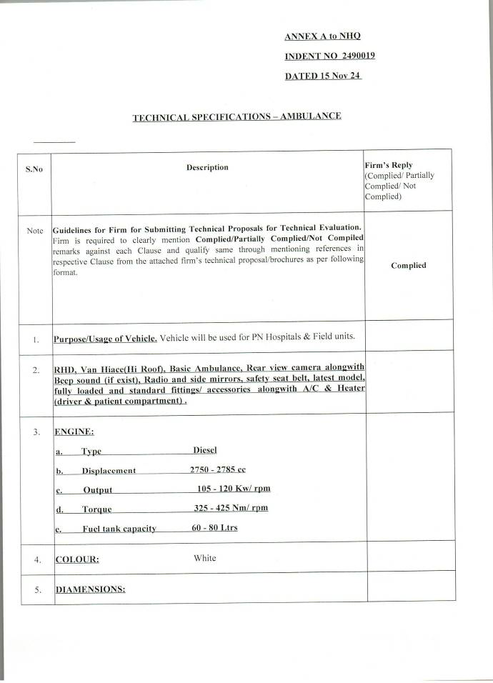

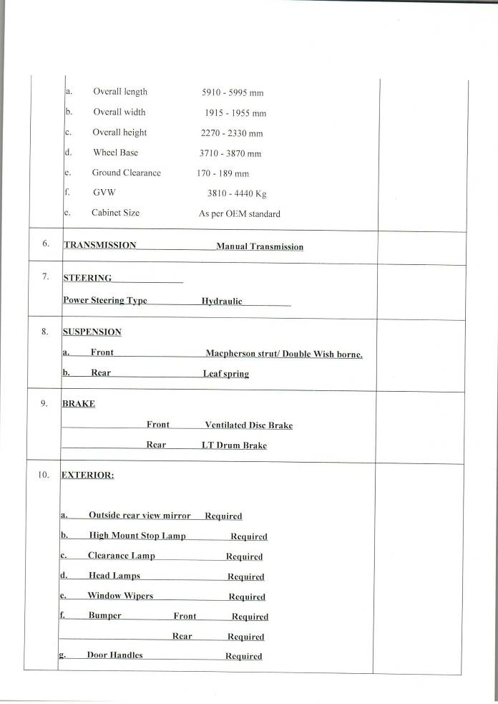

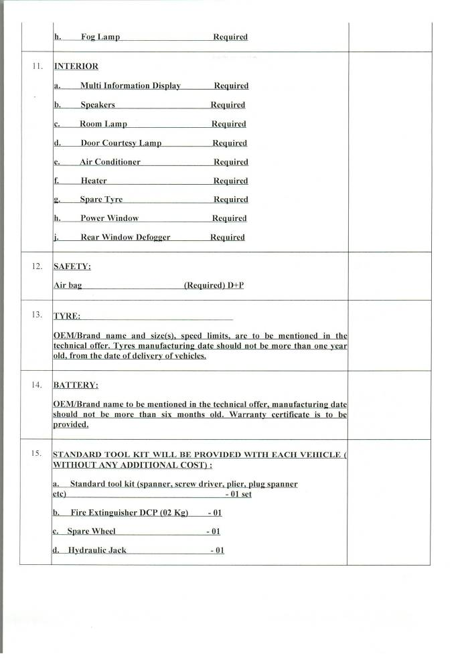

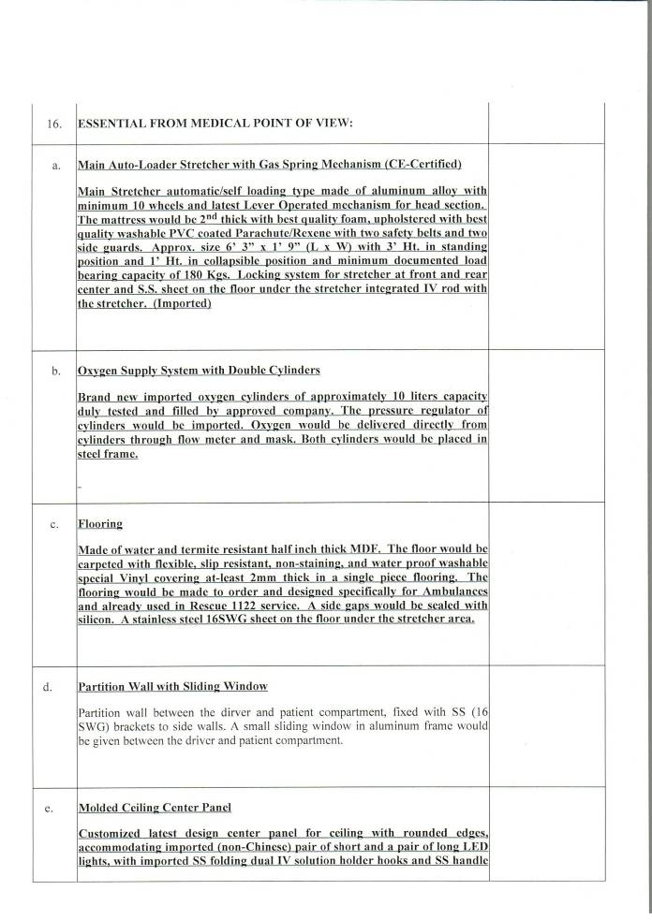

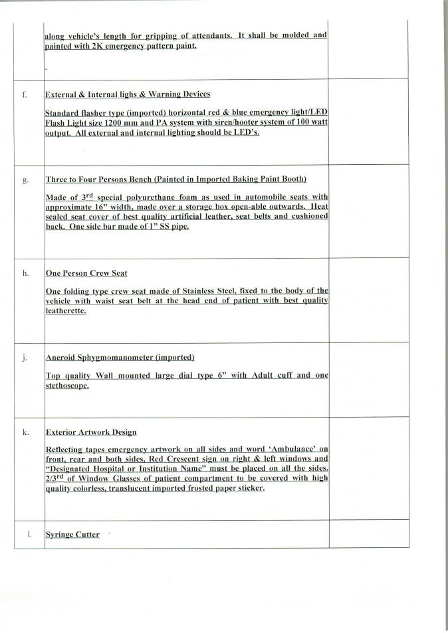

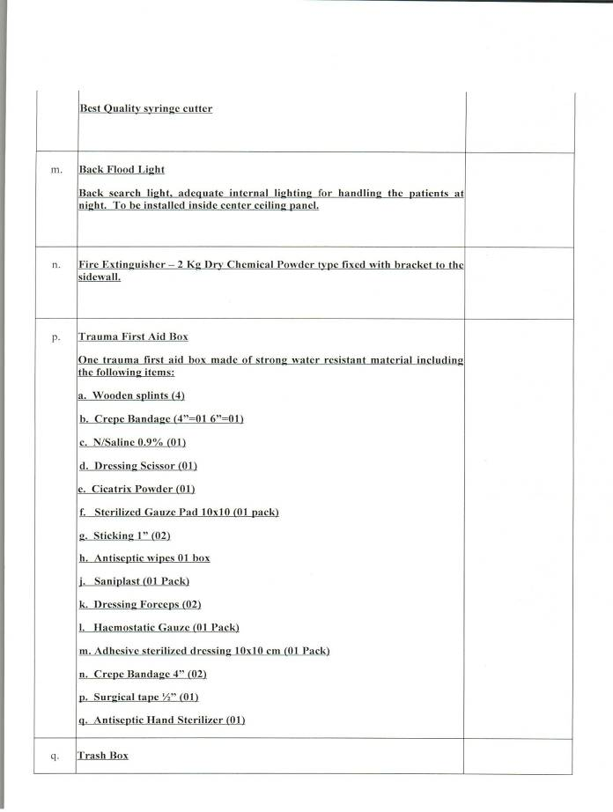

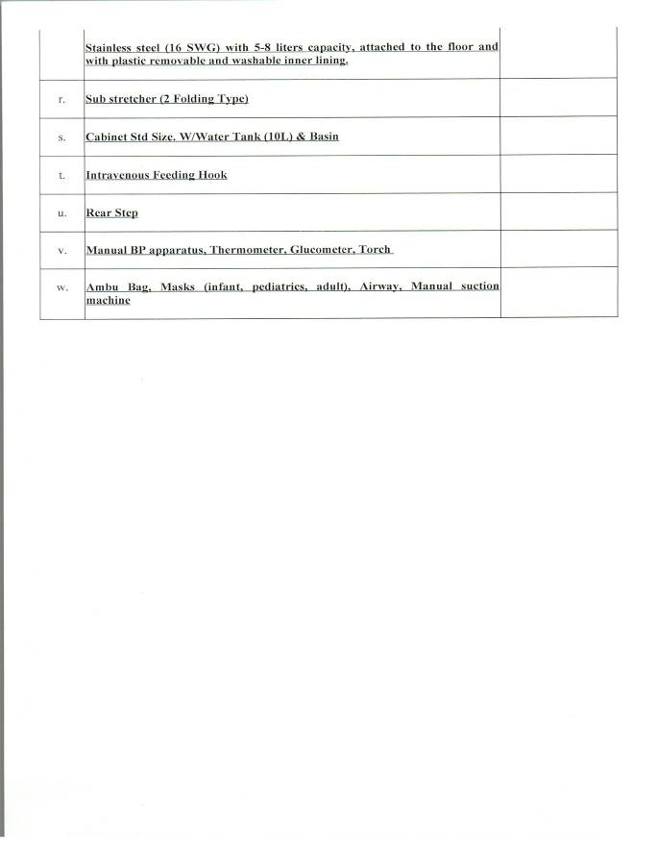

ANNEX B TO NHQ
INDENT_2490019_
DATED_15 Nov 24

GENERAL REQUIREMENTS /INSTRUCTIONS

S.No | Description | Firm’s Reply  (Complied/  Partially Complied/  Not Complied)
Note | Guidelines for Firm for Submitting Technical Proposals for Technical Evaluation. Firm is required to clearly mention Complied/Partially Complied/Not Compiled remarks against each Clause and qualify same through mentioning references in respective Clause from the attached firm’s technical proposal/brochures as per following format. | Complied
1 | SCOPE OF SUPPLY/ WORK  The Supplier undertakes to deliver vehicles including Supplies and Services to the Purchaser on FOR/DDP Karachi/Islamabad basis as per INCOTERMS 2020 as per details specified in Annex-A (Technical Specifications) and General Terms and Conditions given at Annex-B to this Indent.  The Supplier shall, in accordance with the terms and conditions as set forth in the Indent, with due care and diligence, provide the vehicles and supply the Services within 04 months after CED.
2 | SCHEDULE OF PAYMENTS  All payments to the Supplier shall be released through CMA(DP) on achievement of respective milestones as mentioned below or as negotiated by DP (N):-

- 60% payment on completion of following:

  - Delivery on FOR/DDP Karachi/Islamabad alongwith tools/stores.
  - Joint inspection.
  - Provision of all documents.

- 20% payment on completion of following:

  - Successful completion of test/trials of vehicle complying all specification/ acceptance criteria and issuance of final acceptance certificate by end user.

  - Satisfactory conduct of operator & maintainer training.

- 20% payment on issuance of CRV by consignee.

3 | PERFORMANCE BANK GUARANTEE (PBG)  To ensure timely and correct supply of stores, the Supplier shall furnish an unconditional Performance Bank Guarantee in favour of CMA(DP), Rawalpindi within 30 days of signing of the contract from a scheduled bank for an amount equal to 10% of the total Contract value (on a Judicial Stamp Paper) of appropriate value as per prescribed format. This PBG shall remain valid till 60 days beyond completion of warranty period of supplied systems.
4 | CONTRACT EFFECTIVE DATE (CED)  CED shall be established and notified by the Purchaser upon completion of following pre-requisites:  - Contract signing.  - Approval of Export License (if applicable).  - Submission of BGs by the Supplier.
5 | PRICES OF THE ITEMS  The Supplier should mention the price of all deliverables (i.e. Equipments/ Services, Spares, Documentation, Test Bench/ Tools/ Test Equipment, Trainings, Installation/ Integration, Test/ Trials/ Commissioning (Acceptance Trials etc where applicable) separately in financial quote. The same are to be subsequently incorporated in the contract document.
6 | EXPORT LICENSES/ PERMIT/ END USER CERTIFICATE (EUC)  The Supplier shall be responsible to apply in the correct form and in due time for all applicable permits and export licenses etc. outside Pakistan from the related government(s), for the Goods and Supplies.  Upon signature of the Contract but before CED, the Supplier shall apply for any necessary export licenses or other government approvals outside Pakistan in relation to any Supplies to be provided by the Supplier to the Purchaser pursuant to the Contract whether applicable to its country or any other country item where

Supplies originate. The Purchaser is responsible for issuing the EUC as per the required format by respective OEMs or governments within 30 (thirty) days on receipt of the request of the Supplier.

In case any import/export licenses cannot be obtained from the countries where certain, Supplies or parts thereof shall be procured; in such a case or in case of technical reasons, the requirement/issue shall be brought in the notice of the Purchaser within shortest possible time with alternate options available with the Supplier. The Purchaser shall have the right to accept or propose alternates for the needful. Alternate options shall be finalized after mutual agreement between the Parties to be properly endorsed by means of an Amendment to Contract.

The Parties acknowledge that being granted any import license that may be required by applicable law is beyond the reasonable control of the Supplier and as such, the Supplier is not responsible that any such import/export licenses shall be granted by the competent authorities. In such event, the Parties shall promptly confer with one another and with their respective legal counsel to discuss and agree upon a mutually acceptable course of action and solution.

After the Export License/ Permit regarding the export of the Supplies into Pakistan has been granted by the competent authorities (constituting one of the conditions regarding CED to result in effectiveness of this Contract), any refusal, revocation, denial or the like as regards to import/export licenses would not be deemed to be an event of Force Majeure. If required, provision of End User Certificate or any other documents or information reasonably required to the Supplier in due time is the responsibility of the Purchaser.
7 | CUSTOMS, IMPORT DUTIES, TAXES AND OTHER CHARGES  The Purchaser shall pay all applicable customs, import duties taxes and other charges due on the Vehicle payable upon its importation into the country of destination.  The Supplier shall pay all applicable taxes, assessments, duties, levies or charges levied in the country of the manufacturer of the vehicle in connection with the supply by the Supplier of vehicle.  All amounts stated to be payable by Purchaser pursuant to this Contract exclude any value added tax (VAT), sales tax, service tax, Goods and Services Tax (GST), taxes on turnover or similar taxes. If the supply of Vehicle or Services hereunder are chargeable to any value added tax, sales tax, service tax, Goods and Services Tax (GST), taxes on turnover or similar taxes inside country of

destination, and such taxes are not recoverable by the Supplier then such taxes shall be paid and borne by the Purchaser.

Purchaser shall pay and bear all other taxes, assessments, duties, levies or charges by whosoever levied in the country of destination of the Vehicle.

If Purchaser is required by any law to make any deduction or withholding from any amount payable to Supplier under this Contract, then the sum payable in respect of which such deduction or withholding is required to be made shall be increased to the extent necessary to ensure that, after the making of such deduction or withholding, Supplier shall receive (free from any liability in respect of any such deduction or withholding) a net sum equal to the amount which it would have received had no deduction or withholding been required to have been made. Purchaser shall pay any such withholding or deduction to the relevant authority as required by law and shall promptly provide Supplier with an official receipt or certificate in respect of the payment of the withholding or deduction.
8 | DOCUMENTATION  The Supplier shall provide two sets of following original documents (in English) for each vehicle (where applicable):  - Operator manuals covering comprehensive operating instructions alongwith CDs.  - Maintenance manual and procedures alongwith flow charts and diagrams with circuit diagram (as applicable) with all maintenance routines of the equipment.  - Complete priced spare parts list alongwith Part Nos. to be provided at the time of delivery of stores/spares. List of fast moving items may also be provided.  - Standard maintenance documentation must be provided. Maintenance manuals must cover comprehensive maintenance procedures alongwith flow charts and diagrams (if any).  - Illustrated parts catalogues (IPCs).

9 | SPARES (where applicable)  The list of spares, package shall be based on OEM, experience /practice. The Supplier shall provide 01 year spares and 03 years depot spares as and when required by the Purchaser on payment.
10 | WARRANTY/ GUARANTEE  - Warranty period of all items/ vehicle except defective/non-operational shall commence from the date of acceptance of Vehicle, whereas warranty of defective/non-operational equipment (at the time of commissioning/ acceptance) shall commence after defect rectification of equipment.  - The vehicle and all its associated accessories should be warranted against DPL-15 by the Supplier for a period of 01 year, for all defects in hardware from the date of final acceptance by PN. Software (where applicable) provided with the systems /vehicle should also have warranty for a minimum period of 05 years for any bugs found in operations. The Supplier shall provide/incorporate all software updates in this period.  - The Supplier should provide guarantee that the article supplied are of latest version and all modifications/up gradation have been incorporated in the equipment being supplied.  - The Supplier should provide guarantee that the stores produced are of current production and brand new, in accordance with approved drawing, and in all respects. The materials used, whether or not of his manufacture should also be in accordance with the latest appropriate standard specifications.  - The Supplier shall provide guarantee for 10 years supportability of the vehicle and software (where applicable) for at least 05 years after acceptance of the vehicle/accessories.

11 | RISK & EXPENSE  In the event of failure on the part of Supplier to comply with the contractual obligation, the contract shall be cancelled at the risk and expense of the firm.
12 | ACCEPTANCE CRITERIA  - The Supplier should start formulating the criteria for acceptance of vehicle after 15 days of contract signing (both hard and soft copies in English) after necessary approval by PN. The final acceptance procedure may be made by PN, taking into consideration the trial procedures recommended by the Supplier, vehicle specification provided by the Supplier and PN own experience/expertise or as per the mutually agreed timeline as defined in the contract.  - The vehicles shall undergo extensive acceptance trials prior final acceptance.  - The final acceptance certificate should be signed by PN only after successful completion of all Acceptance trials.  - Vehicles acceptance shall be based on operational performance through practical verification as per stated specifications of offered vehicles for a test period of 15 days (may be extended if discrepancies are observed).
13 | TECHNICAL ASSISTANCE  The Supplier should be responsible for successful Tests/Trials of the vehicle on site/Firm premises in Pakistan. The technical assistance by the Supplier during warranty period should be free of cost and on request basis to the satisfaction of during warranty period should be free of cost on request basis to the satisfaction of Purchaser.
14 | INSPECTION OF VEHICLE/ ACCEPTANCE TEST PROCEDURE  - The vehicle shall be Jointly inspected at firm premises and accepted by the PN Inspection Authority i.e CINS. CINS may constitute the inspection team

comprising of following officers/ Reps and may also co opt any other member, if required:

- Reps of Supplier
- Rep of concerned depot
- Rep of CINS
- Rep of End User

- The inspection team shall inspect and test the vehicles to confirm their conformity to the contract specifications.

- The conditions of the contract and technical specifications shall specify inspections/ tests criteria as required by the Purchaser and place of conduct.

- Purchaser shall notify the Supplier in writing of the identity to any representatives entrusted for this purpose.

- If any inspected or tested vehicle fail to conform to the specifications, Purchaser may reject them and the Supplier shall either replace the rejected vehicles or make alterations necessary to meet specification requirements free of cost to Purchaser.

- Purchaser’s right to inspect, test and where necessary, reject the vehicles after arrival in Pakistan (if applicable) shall in no way be limited or waived by reasons of the vehicles having previously been inspected, tested and passed by Purchaser or its representative prior to the vehicles shipment from the country of origin.

g. Joint Inspection Team will be carry out inspection of vehicle including the following test:

(i). Road test.
(ii). Brake test.
- Shower test.
- Performance test.

h. Brochure/ detail technical specification/ drawing of the vehicle model that will be accepted during TSR process to be included in contract to avoid problem during inspection/ acceptance process.
15 | DISCREPANCY  The Supplier shall render a discrepancy report to all concerned within 30 days after receipt of stores/vehicle for discrepancies found in the consignment. The quantities found short or defective are to be made by the Supplier, without any additional cost on “DDP “consignee’s warehouse “within 30 days.
16 | COMPENSATION ON BREACH OF CONTRACT  If the Supplier fails to supply contracted vehicles or contract is cancelled either on RE or without RE or contract become ineffective due to default of Supplier or vehicles equipment declared defective and caused loss to the Government, Supplier shall be liable to pay to the Government compensation for loss or inconvenience resulting for his default or from the rescission of his contract when such default or rescission take place such compensation shall be in excess to the RE amount, if imposed by the competent authority. Compensation amount in terms of money shall be decided by the purchase officer and shall be deposited by Supplier in Government treasury in the currency of contract.
17 | CHECKING OF SUPPLIES AT CONSIGNEE'S END

 | Upon arrival vehicles alongwith supplies shall be checked at consignee's end in the presence of the Purchaser and Supplier’s representatives. If for the reasons of economy, or any other reason, the Supplier decides not to nominate his representative for such checking; an advance written notice to this effect shall be given by the Supplier to the consignee prior to or immediately on shipment of stores. In such an event, the Supplier shall clearly undertake that the decision of consignee with regard to quantities and description of the consignment shall be taken, as final and any discrepancy found shall be accordingly made up by the Supplier. In all other cases, the consignee shall inform the Supplier about arrival of consignment immediately on receipt of stores through fax. If no response from the Supplier is received within four (04) working days from initiation of letter through fax, the consignee shall have the right to proceed with the checking without Supplier's representative. Consignee's report on checking of stores shall be binding on the Supplier in such cases.
18 | PENALTY  - The Supplier before making the shipment(where applicable) shall carry out complete test of the vehicle at its facilities to ensure that the same has been manufactured as per specifications. In case the vehicles does not pass the test/ trials, Purchaser has the right to outright reject the equipment or impose penalty at the rate of 10 - 15% of the value of the relevant equipment/ items.  - The penalty shall not absolve the Supplier to undertake the repairs in Pakistan or abroad at his cost and expense including freight charges. This shall be in addition to the penalties and obligations covered in the contract like warranty/ guarantee obligations on Form DPL-15.
19 | CONTRACT COMPLETION CERTIFICATES  Upon completion of all contractual obligations under this Contract, the Supplier shall submit a “No Demand Certificate” to the Purchaser stating that no stores/ goods, Supplies, Services and payments are outstanding. Concurrently, the Purchaser shall certify through a “No Objection Certificate” that the requirement placed by the Purchaser as per terms and conditions set forth in this Contract has been fulfilled. Upon receipt of both certificates, Bank Guarantee(s) shall be returned by CMA(DP) to the Purchaser for onward return to the Supplier.
20 | TECHNICAL SCRUTINY  Technical scrutiny of quotations forwarded by the bidder shall be carried out by a committee nominated by NHQs.

21 | LIQUIDATED DAMAGES (LDs)  Delay in the supply of stores for first schedule/ supply order upto 21 days and for subsequent schedule/ supply order upto 15 days will be regarded as grace period available to the supplier and the delivery date will be considered to have been automatically extended upto that limit without issuance of any formal amendment. For delays beyond 21 days and incase of subsequent schedule/ supply orders for delays beyond 15 days, formal amendment to the DP will be required. For purposes of imposing LD, if and when imposed, grace period will be inclusive i.e LD will be calculated from the original delivery date and not from the expiry of the grace period. LD will be recovered at the rate of upto 2% but not less than 1% of the value of stores supplied late per month or a part of a month for the period exceeding the original DP. The Supplier will not be entitled to any reimbursement of any additional taxes, excise duty, sales tax etc, imposed by the Govt which becomes effective during the grace period and extensions in DP. LD thus imposed will not exceed 10% of the total value excluding taxes/duties, freight, KPT, insurance charges of the stores delivered late.
22 | INTEGRITY PACT  If the Supplier or any of his sub-contractors, agents or servants is found to have violated or involved in violation of the Integrity Pact (format placed at Appendix- I) signed by the Supplier, then the Purchaser shall be entitled to:  - Recover from the Supplier an amount equivalent to ten times the sum of any commission, gratification, bribe, finder’s fee or kickback given by the Supplier or any of his sub-contractors, agents or servants.  - Terminate the Contract and recover from the Supplier any loss or damage to the Purchaser as a result of such termination or of any other corrupt business practices of the Supplier or any of his sub-contractors, agents or servants.
23 | AMENDMENT IN CONTRACT  Amendment in the contract if required shall be processed by Purchaser upon mutual agreement of both parties i.e. Purchaser and Supplier and formally issued through amendment in the contract/corrigendum.

24 | APPLICABLE LAW, DISPUTES AND ARBITRATION  Parties shall make their attempt that all disputes arising under this contract shall be resolved through mutual negotiation of both parties. In the event that either party shall perceive such mutual negotiation to be making insufficient progress towards settlement of dispute(s) at any time, then such party may by written notice to the other party refer the dispute(s) to final and binding arbitration as provided below:  - The dispute shall be referred for adjudication to two arbitrators one be nominated by each party who before entering upon the reference shall appoint an umpire by mutual agreement, and if they do not agree a judge of the Superior Court shall be requested to appoint the umpire. The arbitration proceedings shall be held in Pakistan and under Pakistani Law.  - The venue of arbitration shall be the place from which the contract is issued or such other places as the Purchaser at his discretion may determine.  - The arbitration award shall be firm and final.  - In the course of arbitration the contract shall be continuously executed except that part which is under arbitration.  - All proceedings under this clause shall be conducted in English language and in writing.
25 | FORCE MAJEURE  - The Parties will not be held responsible for any non- fulfillment or delay in carrying out the contractual obligations due to event of Force Majeure such as Acts of God (earthquake, flood, fire, typhoon, hurricane, mass epidemic diseases), War (military actions, subversive activities or sabotages), Riots, Civil Commotion, Strike, Lockouts, Prohibitive measures of Governments (prohibition of trade relations with certain countries as a result of United Nations sanctions imposition)' directly affecting the Parties and any events or circumstances on which the Parties has no control.  - In order to be deemed force-majeure, the said events should be of extraordinary, unpredictable and unavoidable nature, and occur after this Contract

comes into force and be beyond control of the Parties.

- Should the force-majeure circumstances occur, the suffering Party must notify in writing the other Party of such situation within 30 (thirty) days from occurrence thereof The said notice should contain information about the nature of the circumstances and, if possible, contain an evaluation or estimate of their probable impact upon performance of obligations under the Contract, as well as the time required for such performance.

- Upon termination of the above-mentioned circumstances, the suffered Party should promptly give a relevant written notice to the other Party. The said notice should specify the time, within which performance of obligations under the Contract is being suggested.

- Within reasonable time, the Party exposed to force-majeure should transfer to the other Party a Certificate issued by the legal Authorities, as an evidence of occurrence of the force- majeure situation.

- Should the force-majeure situation occur, the timing of performance by the Parties of their respective obligations under the Contract shall be extended adequately, by adding on the duration of such circumstances and consequences thereof.

- Should the force-majeure circumstances continue for more than consecutive 60 (sixty) days, the Parties shall negotiate and coordinate appropriate measures needed to be taken in order to perform their respective obligations in Contract. If duration of such circumstances excess months and the Parties fail to agree on further measures needed to perform their respective the Contracting Party (Purchaser) shall have the terminate the Contract, whether partially or wholly any subsequent claims, by sending a written notice to the other Party (Seller).

- The Purchaser may not claim LD in relation to delivery provided that such delays have been occurrence of a force-majeure event.
26 | TERMINATION OF CONTRACT  If at any time during the currency of the contract the Purchaser decides to terminate the contract for any reason whatsoever (other than for reasons of Non- Delivery) he shall have right to do so by giving the Supplier a registered notice to

that effect. In that event the Purchaser shall accept delivery at the contract price and terms of such stores/goods/services/vehicles which are in the actual process of manufacture that is completed and ready for delivery within thirty days after receipt by the Supplier of such notice.

In the case of remainder of the undelivered stores/goods/services the Purchaser may elect either:

- To have any part thereof completed and take the delivery thereof at the contract price or.

- To cancel the remaining quantity and pay to the Supplier for the articles or sub-components or raw materials purchased by the Supplier and are in the actual process of manufacture at the price to be determined by the Purchaser. In such a case materials in the process of manufacture shall be delivered by the Supplier to the Purchaser.

- No payment shall however be made for any materials not yet in the actual process of manufacture on the date notice of cancellation is received.
- Should the Supplier fail to deliver vehicles including supply and services in time as per terms of contract or fail to render Bank Guarantee within the stipulated time period or any breach of the contract the Purchaser reserves the right to terminate/cancel the contract fully or any part thereof at the risk and expense (RE) of the Supplier. If due to any reasons Purchaser fails to perform its obligations required for the smooth conduct and management of the Contract, Supplier has a right to initiate legal proceedings.
27 | CONFIDENTIALITY  The Supplier and the Purchaser shall keep confidential all information of the other party, whether designated as confidential or not, obtained under or in connection with the Contract and shall not divulge the same to any third party without the written consent of the other party. The provisions of this clause shall not apply to any information in the public domain otherwise than by breach of the Contract; or information obtained from a third party who is free to divulge the same.  The Supplier and the Purchaser shall divulge confidential information only to those employees who are directly involved in the Contract or have use of equipment and/or software used in connection with the Contract and shall ensure that such employees are aware of and comply with these obligations as to confidentiality.

 | The Supplier shall undertake that any information about the sale/ purchase of the stores under this contract shall not be communicated to any person, other than the manufacturer/ Supplier/company’s lawyer(s), or to any press or agency not authorized by the Purchaser to receive it. Any breach on this account shall be punishable under the Official Secret Act-1923 in addition to termination of the Contract at the risk and expense of the Supplier.
28 | LONG TERM LOGISTIC SUPPORT/REPAIR & MAINTENANCE  The Supplier shall guarantee to supply the necessary spares /facilitate repair/maintenance for next 10 years from the date of its final acceptance of the system/ vehicle by Purchaser. All the COTS (Commercial off the Shelf) items supplied as part of the main equipment/ vehicle, OEM shall indicate their source of availability.  The Supplier shall provide alongwith the offer the name of manufactures of all the major sub-assemblies and associated accessories of the offered system. The Supplier shall provide standards/ specifications certificate referred to or used for the equipment and its accessories.
29 | SEVERABILITY  The invalidity or unenforceability of any term or condition of the Contract shall not affect the validity or enforceability of the remaining terms and conditions. These shall remain in full force and effect and the Contract shall thereupon be interpreted and amended in compliance with the pertinent statutory terms and conditions to be mutually discussed between both Parties. Such discussions shall, as far as be possible, ensure the Defence needs/concerns of the Purchaser and commercial interest and intent of the Supplier in respect of the terms and conditions which are concerned. Provided that if the foregoing invalidity or unenforceability term and condition substantially alter the underlying intent of the Contract or the invalid or unenforceable term or condition comprises an integral part of or is otherwise inseparable from the remainder of the Contract, then the Parties shall without further delay, meet to consult each other and reach agreement thereon.  Failure by either Party at any time to enforce any of the provisions of the Contract shall not be considered as a waiver by the Party concerned of any such provision or in any way affect the validity of the Contract or any part thereof or any other rights of either Party. Such failure shall only inhibit the rights of the Party concerned to claim costs/expenses incurred or to impose Liquidated Damages (financial or otherwise) for defaults, in respect only of the said non-enforced provisions.

30 | ASSIGNMENT AND SUBCONTRACTING  Neither Party shall assign any of its rights or obligations (in whole or in part) under the Contract without the prior written consent of the other Party, which shall not be unreasonably withheld.  The Supplier shall not subcontract any part of the Contract without the written consent of the Purchaser, which shall not be unreasonably withheld.
31 | OWNERSHIP OF CONTRACT  In the event of a change of ownership of Supplier, the Supplier shall ensure that the legal instrument or mode by which the change of ownership takes place shall have specified provisions to the effect that:  - Such change of ownership shall not in any way change, alter or modify the Terms and Conditions of this Contract, and  - The Supplier under new ownership shall continue to be bound by the Terms and Conditions of this Contract.
32 | INDEMNITY  In the framework of the implementation of this project, both Parties shall waive off any claim against each other regarding every claim for indemnity for the losses caused to their respective personnel or respective personnel of sub- contractors/agents and their properties. However, if these losses result from deliberate fault or unmistakable error or gross negligence of Supplier or his sub- contractors/agents and/or the Purchaser, the Party involved shall bear alone the burden of the damage repairs.
33 | CERTIFICATE OF CONFORMANCE (COC) BY OEM  Supplier shall provide correct and valid e-mail and fax No. to CINS and DP(N). Supplier/ contracting Supplier shall either provide OEM Conformance Certificate to CINS or is to be e-mailed to CINS under intimation to DP(N). Hard copy of COC must follow in any case through courier. On receipt, CINS shall approach the OEM for verification of Conformance Certificate issued by the OEM. Companies/ Suppliers rendering false OEM Conformance Certificates shall be  black listed.

34 | BIDDING PROCEDURE  This tender shall be floated on Open Tender basis using Single Stage Two Envelope Bidding procedure.
35 | LANGUAGE, MEASUREMENTS AND WORKING METHODS  All drawings, data-files in soft media, Man-Machinery Interface (MIMI) of software and hardware, all marking and identification systems, and all other documentation required to be produced or delivered to the Purchaser under the Contract shall be written, and meetings conducted, in the English language. Measurements shall be in metric units of measurement unless otherwise specified.

36 | OEM’S SPECIFICATIONS: Following is to be provided alongwith technical offer:  - Copy of OEM’s list of standard accessories/fittings etc.  - Details of model code of engine/chassis etc.  - List of standard tool kit.
37 | REJECTION OF VEHICLES BE HANDLED AS GIVEN BELOW:  In the event of any vehicle failing to conform to the specification given in the contract, or the failure of supplier in performing any of the contractual obligations stipulated in the contract. The purchaser shall have the right to reject the same. The purchaser will then be at liberty to:  - ​ Allow the supplier to present vehicles in replacement of those rejected within the delivery period specified in the contract, the supplier bearing the cost of freight on such replacement without being entitled to any extra payment, or.  - ​ Buy the quantity of the vehicle rejected or others of a similar nature from elsewhere at the risk and expense of the supplier without affecting the supplier’s liability as regards supply of any further consignments due under the contract, or.  - Terminate the contract and recover from the supplier the actual loss the purchaser thus incurs by purchasing the vehicle from elsewhere.
38 | COUNTRY OF ORIGIN: Pakistan

39 | DELIVERY OF VEHICLE: Delivery should be within 06 months after signing of contract on FOR/DDP Karachi/Islamabad basis, at a place nominated by Pakistan Navy i.e. Karachi/ Islamabad.
40 | COMPARISON: The bidders are to provide a comparative chart clearly showing the specifications as per tender. Any deviation must be highlighted and justified.
41 | PRICE VARIATION: Prices in the schedule of stores of this contract are firm and final. The stores must be of brand new manufacture.

